Waveforms obtained from the uploaded simulation model are not accurate so redesign the simulation models

& obtain exact waveforms by verify (i) Fig. 3.3-7 Dynamic response of SCIG with direct grid connection. 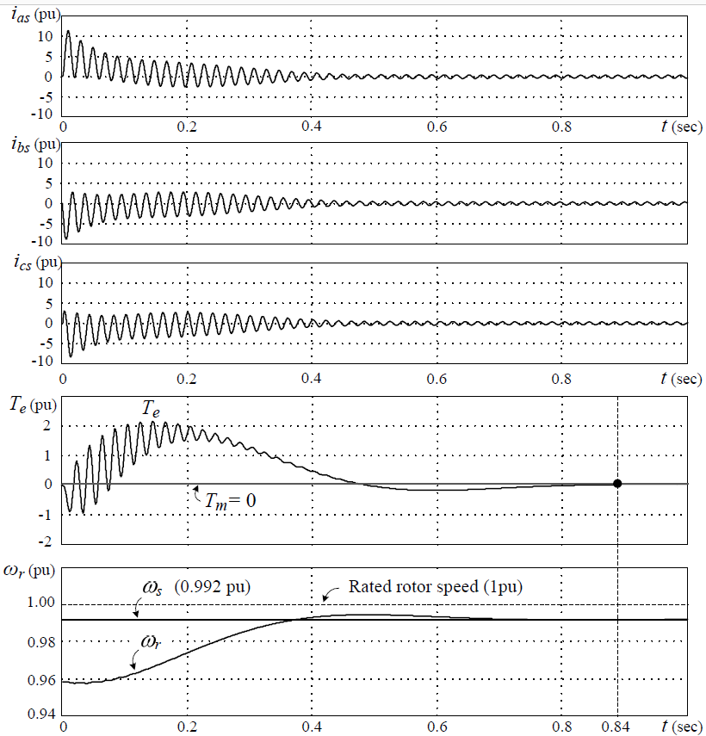

& (ii) Fig. 3.3-8 Dynamic response of SCIG with a fixed rotor speed during direct grid connection.

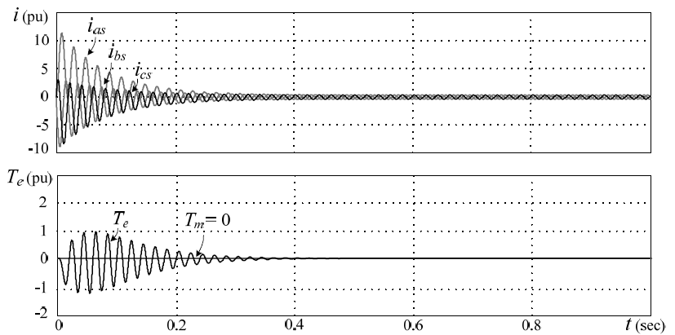

Email simulation model(re-designed by yourself) along with a report(soft & hard copy).Discuss waveforms behavior.

Submission date: 5th March